Hamzah , Anil

Abstract

This is the Design Document for the Zombie Master game, and will detail all aspects of the games design. It will also contain info on how we intend to code the game, including classes and ways we will implement certain features.

Design Document

Zombie Master Game

Contents

Game Design 1

Gameplay 1

Graphics 1

Sound 1

Code Design 1

Classes for Game engine 1

# Game Design

## Gameplay

The game will feature two different sides, and will contain only a multiplayer mode as its core. The sides are the human/survivor side, and the “zombie master” side. Both players will play from a top down perspective.

The human side will control a single human per player, who can move around, pick up items and equipment, use said items in combat or other ways and do objectives that are on the map. I expect gameplay to be similar to the source mod Zombie Master. Where the humans had to do certain things around the map to win the level.

The Zombie Master will play like an RTS, and will control monsters that can be spawned around the map. There will also be traps on the map, that either the zombie master can make or that are inbuilt onto the map itself.

The goal of each “level” will not have to be the same for the humans, but for the zombie master it will nearly always be to kill all humans on the map. The humans may have to find certain items around the map, or defend a location for an amount of time.

## Graphics

The game will be top down, and will be inspired by the games Teleglitch and hotline Miami.

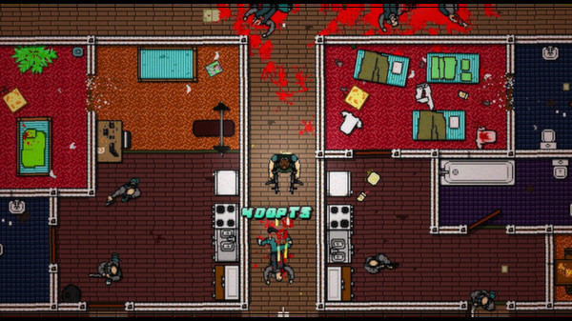

Hotline Miami top down view

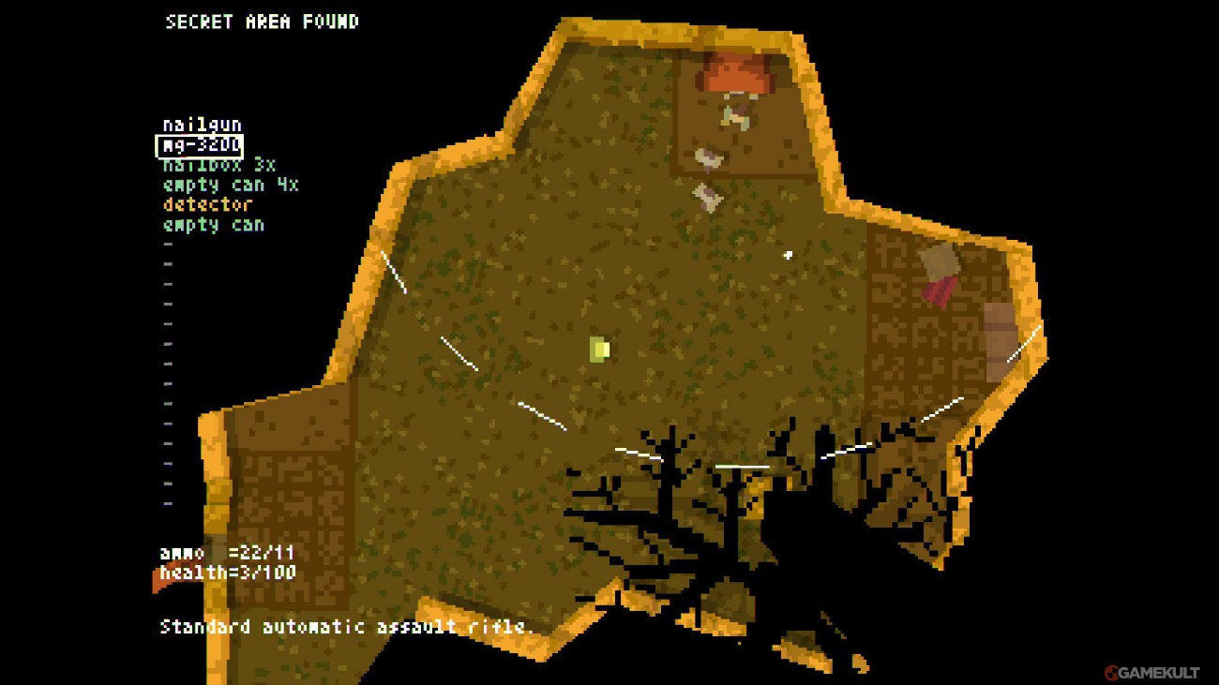

Teleglitch top down view, note the equipment on the left side

## Sound

No idea what the sound will be like for the game. For now, we will just use basic sounds for everything.

# Code Design

## Classes for Game engine